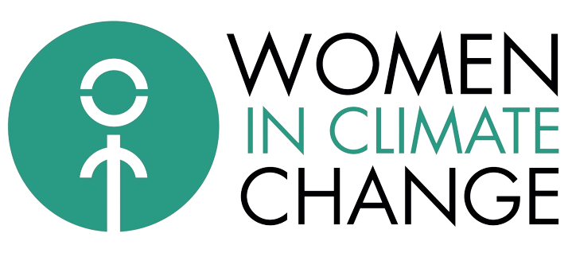

Yaoundé, Cameroon

Date: 18/03/24

Object: Concept Note - Awareness-raising activity to fight against climate change in secondary schools in the city of Yaoundé.

Targets:

- Collège Vogt ;
- Collège la retraite ;
- Centre éducatif ;
- Lycée Leclerc ;
- Collège Jean Tabi.

Dear potential partners,

We are pleased to present to you this concept note describing the progress of activities for our awareness raising project on the fight against climate change, aimed at raising awareness among students in schools in the city of Yaoundé about the issues of climate change and the importance of the empowerment of women and girls in this context.

Description of activities

Phase 1: Identification of schools that respect sustainable development goals.

- Request for authorization from the managers of said schools;
- Identification of the environment clubs of each school;
- Ensure the registration of students from the environment clubs of each school for the activity.

Phase 2: Identification of partners and fundraising

- Identification of strategic partners (Name recycling);
- Identification of financial partners;
- Fundraising campaign (Honorary members, donations and grants);

Phase 3: Workshop planning and presentation

- For each partner school, we will plan a series of interactive workshops and presentations.
- Artistic activity (Students will be asked to make drawings on signs);
- Plastic waste recycling activity;
- These sessions will be led by members of WICC (Presentation of the association and its objectives, awareness of the importance of preserving the environment and the effects of climate change, Discussion on environmental professions);
- We will discuss different aspects of climate change, women's empowerment and collective action (Discussion on the involvement of women in the fight against climate change).
- Installation of garbage bins in the various schools.

Phase 4: Monitoring and evaluation

- We will put in place a monitoring and evaluation system to measure the impact of our activities and adjust our approach if necessary.
- We will collect data on student participation, their level of knowledge before and after the sessions, as well as their continued engagement in actions related to environmental awareness by setting up a process for monitoring internal activities by the environment club and externally. by WICC.

Partners:

Can be partners:
- National and international organizations working towards sustainable development goals;
- Institutions;
- Civil society organizations;
- Companies working to fight against climate change;
- The media.

We are convinced that this course of activities will achieve our objectives of raising awareness and empowering young people on the issues of climate change and gender. Your support and partnership are essential to the success of this initiative, and we look forward to working together for a more sustainable future.

We are available to discuss this proposal in more detail and explore ways we can collaborate effectively to achieve our shared goals. Please contact us at the following address: djoubainatou11@icloud.com or +237 691 86 85 59.

While waiting for a favorable response, please accept, dear potential partners, the expression of our distinguished greetings.

Sincerely,

Djoubainatou Laminou
Founder & President of the WICC (Women in Climate Change) association
+237 691 86 85 59
djoubainatou11@icloud.com

